Jenkins challenge

Use the below code and implement our CICD stages.
- Source Code:https://github.com/betawins/hiring-app.git
- Repository contains the application code for the hiring app.
- Create one Declarative pipeline job
- Create one Scripted pipeline job
- Create one multi stage pipeline job
- Create one parallel stage pipeline job

- Create one Declarative pipeline job

Declarative pipeline job:

Create new item→select pipeline→save

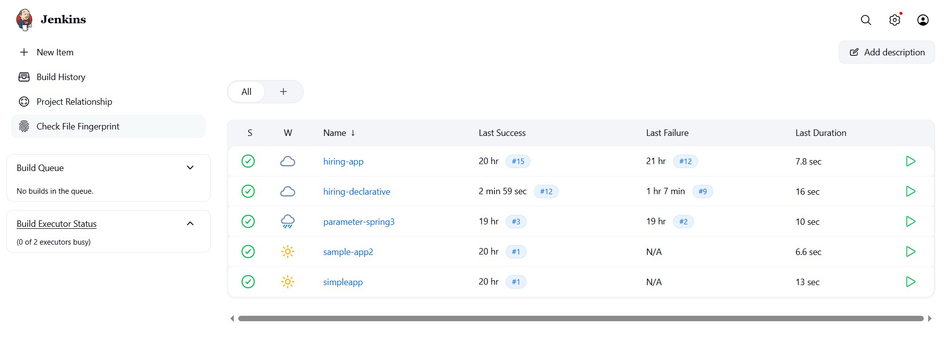

Open job→ click on configure→write pipeline→save& build
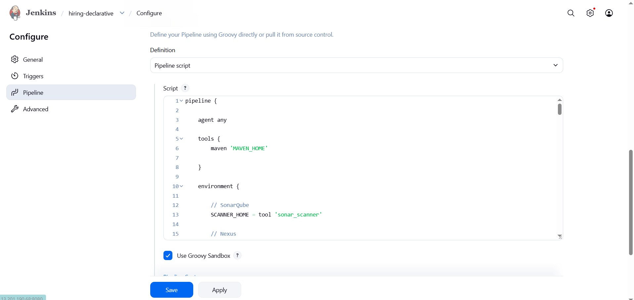
pipeline {

agent any

tools {
maven 'MAVEN_HOME'

}

environment {

// SonarQube
SCANNER_HOME = tool 'sonar_scanner'

// Nexus
NEXUS_VERSION = "nexus3"
NEXUS_PROTOCOL = "http"
NEXUS_URL = "13.232.205.190:8081"
NEXUS_REPOSITORY = "hiring-app"
NEXUS_CREDENTIAL_ID = "nexus"

// Artifact Details
GROUP_ID = "in.javahome"
ARTIFACT_ID = "hiring"
VERSION = "1.0.${BUILD_NUMBER}-SNAPSHOT"

// Tomcat
TOMCAT_URL = "http://13.201.30.120:8080/"
TOMCAT_CREDENTIAL_ID = "tomcat"

// Slack
SLACK_CHANNEL = "jobs"
}

stages {

stage('Clean Workspace') {
steps { cleanWs()
}
}

stage('Clone Source Code') {
steps {

git branch: 'main', url: 'https://github.com/betawins/hiring-app.git'
}
}

stage('Build Application') { steps {

sh "${tool 'MAVEN_HOME'}/bin/mvn clean install"
}
}

stage('Run Unit Tests') { steps {

sh 'mvn test'
}
}

stage('SonarQube Code Analysis') {

steps {

withSonarQubeEnv('sonarqube') {
sh """
${SCANNER_HOME}/bin/sonar-scanner \
-Dsonar.projectKey=hiring-app \ -Dsonar.projectName=hiring-app \ -Dsonar.sources=.
"""
}
}
}

stage('Package Application') {

steps {

sh 'mvn clean package'
}
}

stage('Archive Artifact') {

steps {

archiveArtifacts artifacts: 'target/hiring.war'
}
}

stage('Upload WAR to Nexus') {

steps {

nexusArtifactUploader(

nexusVersion: NEXUS_VERSION, protocol: NEXUS_PROTOCOL, nexusUrl: NEXUS_URL, repository: NEXUS_REPOSITORY, credentialsId: NEXUS_CREDENTIAL_ID, groupId: GROUP_ID, version: VERSION,
artifacts: [
[
artifactId: ARTIFACT_ID, classifier: '', file: 'target/hiring.war', type: 'war'
]
]
)
}
}

stage('Deploy to Tomcat') {

steps {

deploy adapters: [ tomcat9(
credentialsId: TOMCAT_CREDENTIAL_ID, path: '',
url: "${TOMCAT_URL}"
)
],

contextPath: 'hiring-app', war: 'target/hiring.war'
}
}
}

post {

success {

slackSend( channel: "${SLACK_CHANNEL}",
color: 'good', message: """
SUCCESS:
Job Name: ${env.JOB_NAME}
Build Number: ${env.BUILD_NUMBER}
Build URL: ${env.BUILD_URL}
"""
)
}
failure {

slackSend( channel: "${SLACK_CHANNEL}",
color: 'danger', message: """
FAILED:
Job Name: ${env.JOB_NAME}
Build Number: ${env.BUILD_NUMBER}
Build URL: ${env.BUILD_URL}
"""
)
}
}
}

Build successfully
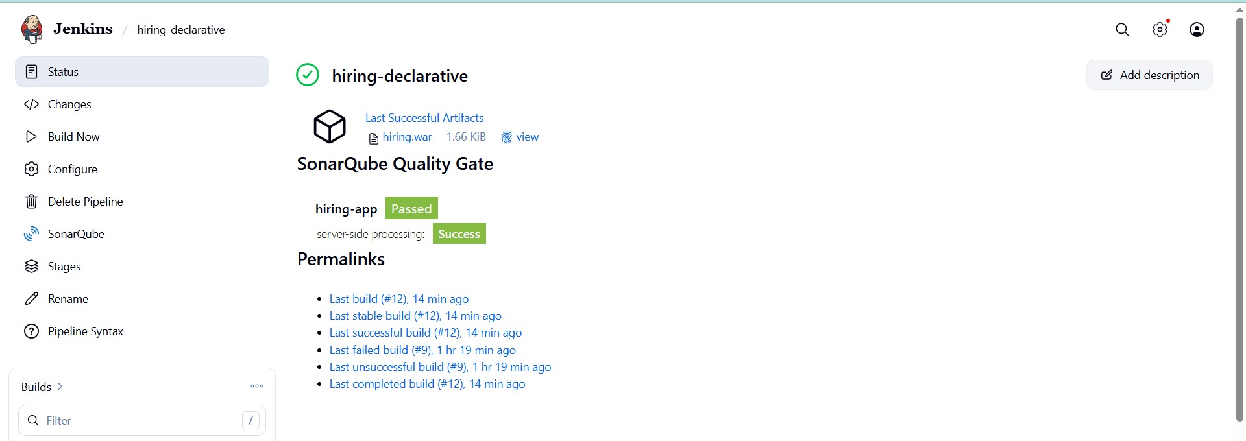
Check console output:
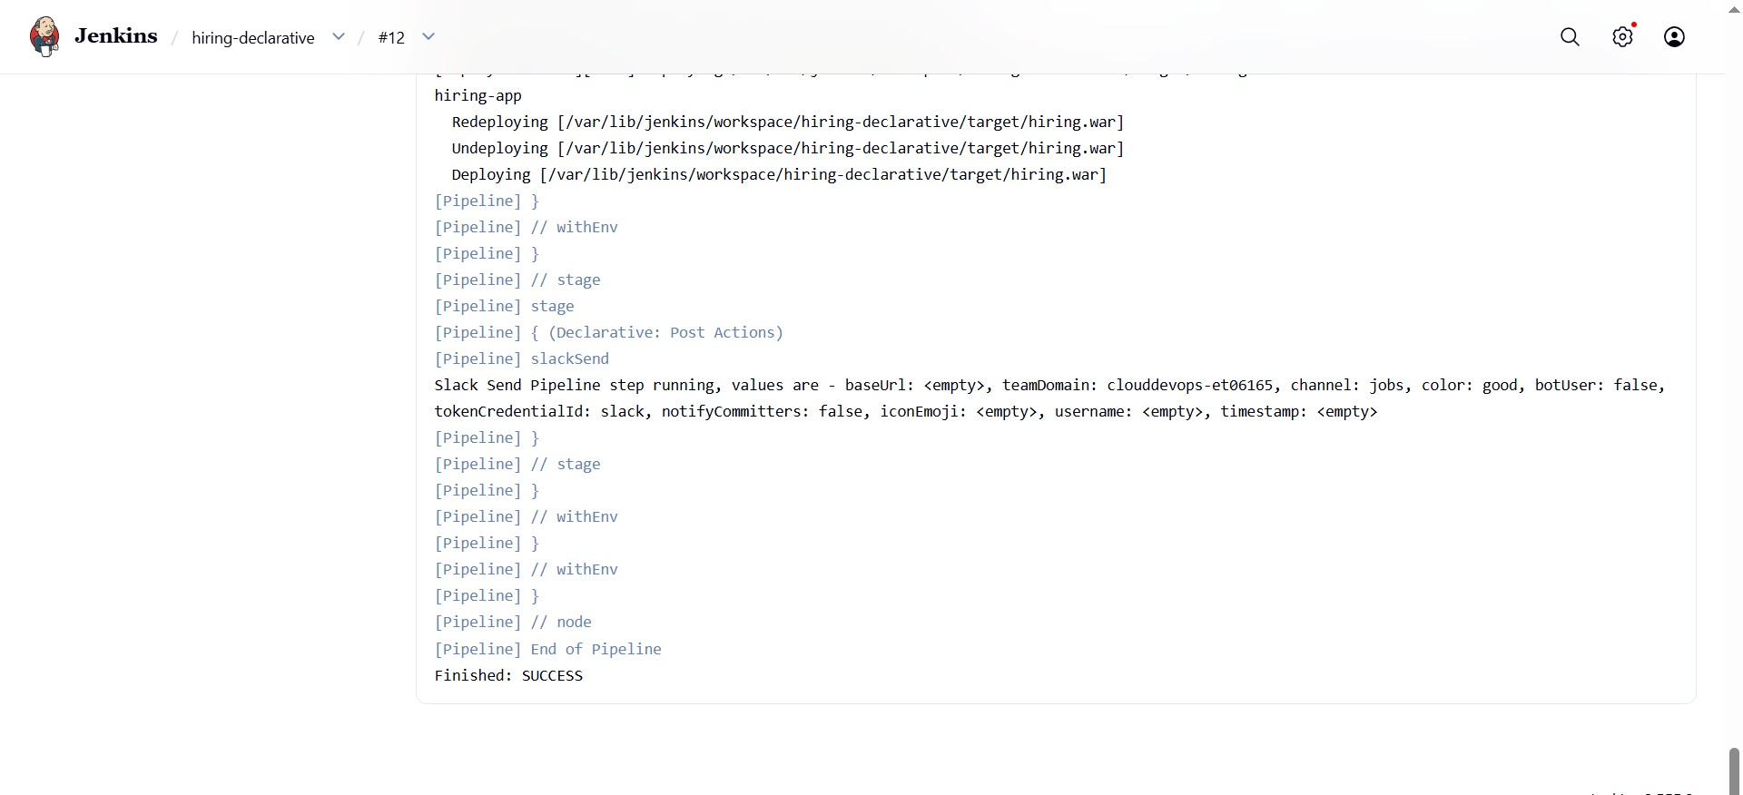

Slack notification
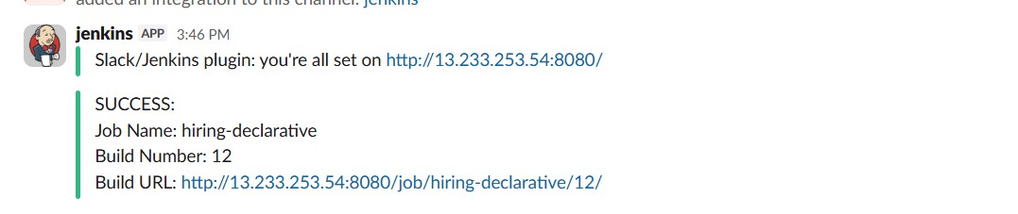

2) Create one Scripted pipeline job

Scripted pipeline job:

Create new item→select pipeline→configure→seclect scripted pipeline
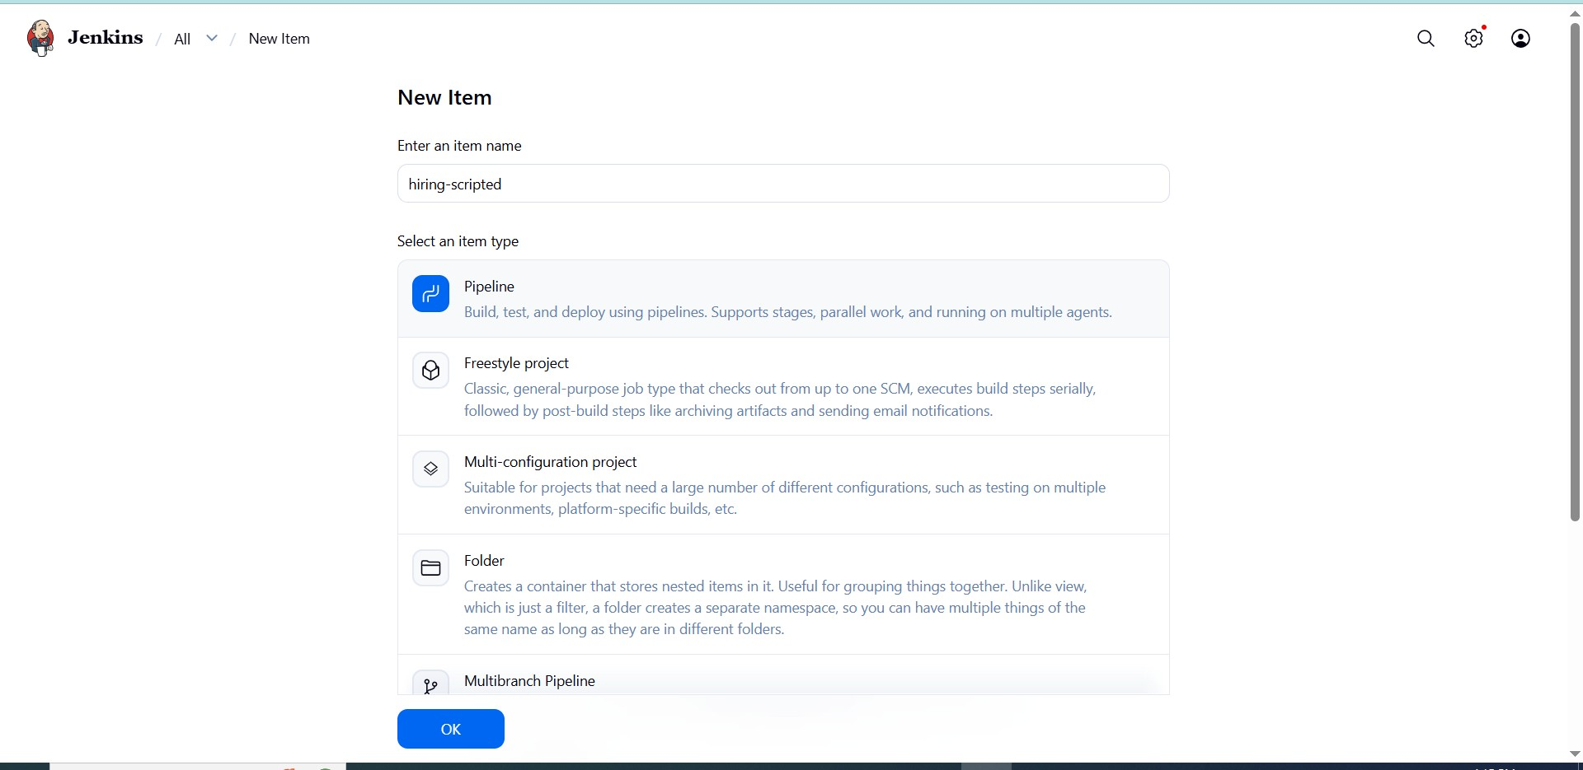

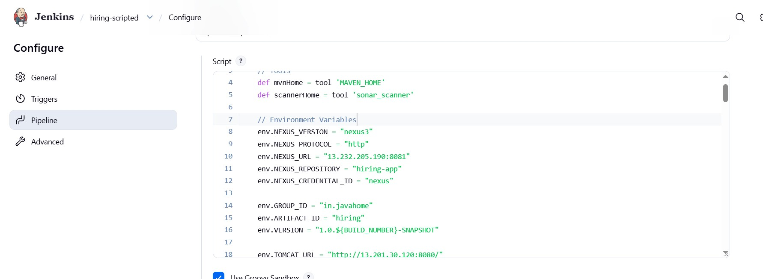

node {

// Tools
def mvnHome = tool 'MAVEN_HOME'
def scannerHome = tool 'sonar_scanner'

// Environment Variables env.NEXUS_VERSION = "nexus3" env.NEXUS_PROTOCOL = "http" env.NEXUS_URL = "13.232.205.190:8081" env.NEXUS_REPOSITORY = "hiring-app" env.NEXUS_CREDENTIAL_ID = "nexus"

env.GROUP_ID = "in.javahome" env.ARTIFACT_ID = "hiring"
env.VERSION = "1.0.${BUILD_NUMBER}-SNAPSHOT"

env.TOMCAT_URL = "http://13.201.30.120:8080/" env.TOMCAT_CREDENTIAL_ID = "tomcat"

env.SLACK_CHANNEL = "jobs"
try {

stage('Clean Workspace') {

cleanWs()
}

stage('Clone Source Code') {

git branch: 'main',
url: 'https://github.com/betawins/hiring-app.git'
}

stage('Build Application') {

sh "${mvnHome}/bin/mvn clean install"
}

stage('Run Unit Tests') {

sh "${mvnHome}/bin/mvn test"
}

stage('SonarQube Code Analysis') {

withSonarQubeEnv('sonarqube') {
sh """
${scannerHome}/bin/sonar-scanner \
-Dsonar.projectKey=hiring-app \ -Dsonar.projectName=hiring-app \ -Dsonar.sources=.
"""
}
}

stage('Package Application') {

sh "${mvnHome}/bin/mvn clean package"
}

stage('Archive Artifact') {

archiveArtifacts artifacts: 'target/hiring.war' }

stage('Upload WAR to Nexus') {

nexusArtifactUploader(

nexusVersion: env.NEXUS_VERSION, protocol: env.NEXUS_PROTOCOL, nexusUrl: env.NEXUS_URL, repository: env.NEXUS_REPOSITORY, credentialsId: env.NEXUS_CREDENTIAL_ID, groupId: env.GROUP_ID, version: env.VERSION,

artifacts: [
[
artifactId: env.ARTIFACT_ID, classifier: '', file: 'target/hiring.war', type: 'war'
]
]
)
}

stage('Deploy to Tomcat') {

deploy adapters: [ tomcat9(
credentialsId: env.TOMCAT_CREDENTIAL_ID, path: '',
url: env.TOMCAT_URL
)
],

contextPath: 'hiring-app', war: 'target/hiring.war'
}

stage('Slack Notification Success') {

slackSend( channel: env.SLACK_CHANNEL,
color: 'good', tokenCredentialId: 'slack', message: """
SUCCESS:
Job Name: ${env.JOB_NAME}
Build Number: ${env.BUILD_NUMBER}
Build URL: ${env.BUILD_URL}
"""
)
}

} catch (Exception e) {

stage('Slack Notification Failure') {

slackSend( channel: env.SLACK_CHANNEL,
color: 'danger', tokenCredentialId: 'slack', message: """
FAILED:
Job Name: ${env.JOB_NAME}
Build Number: ${env.BUILD_NUMBER}
Build URL: ${env.BUILD_URL}
"""
)
}

throw e
}
}

save&build
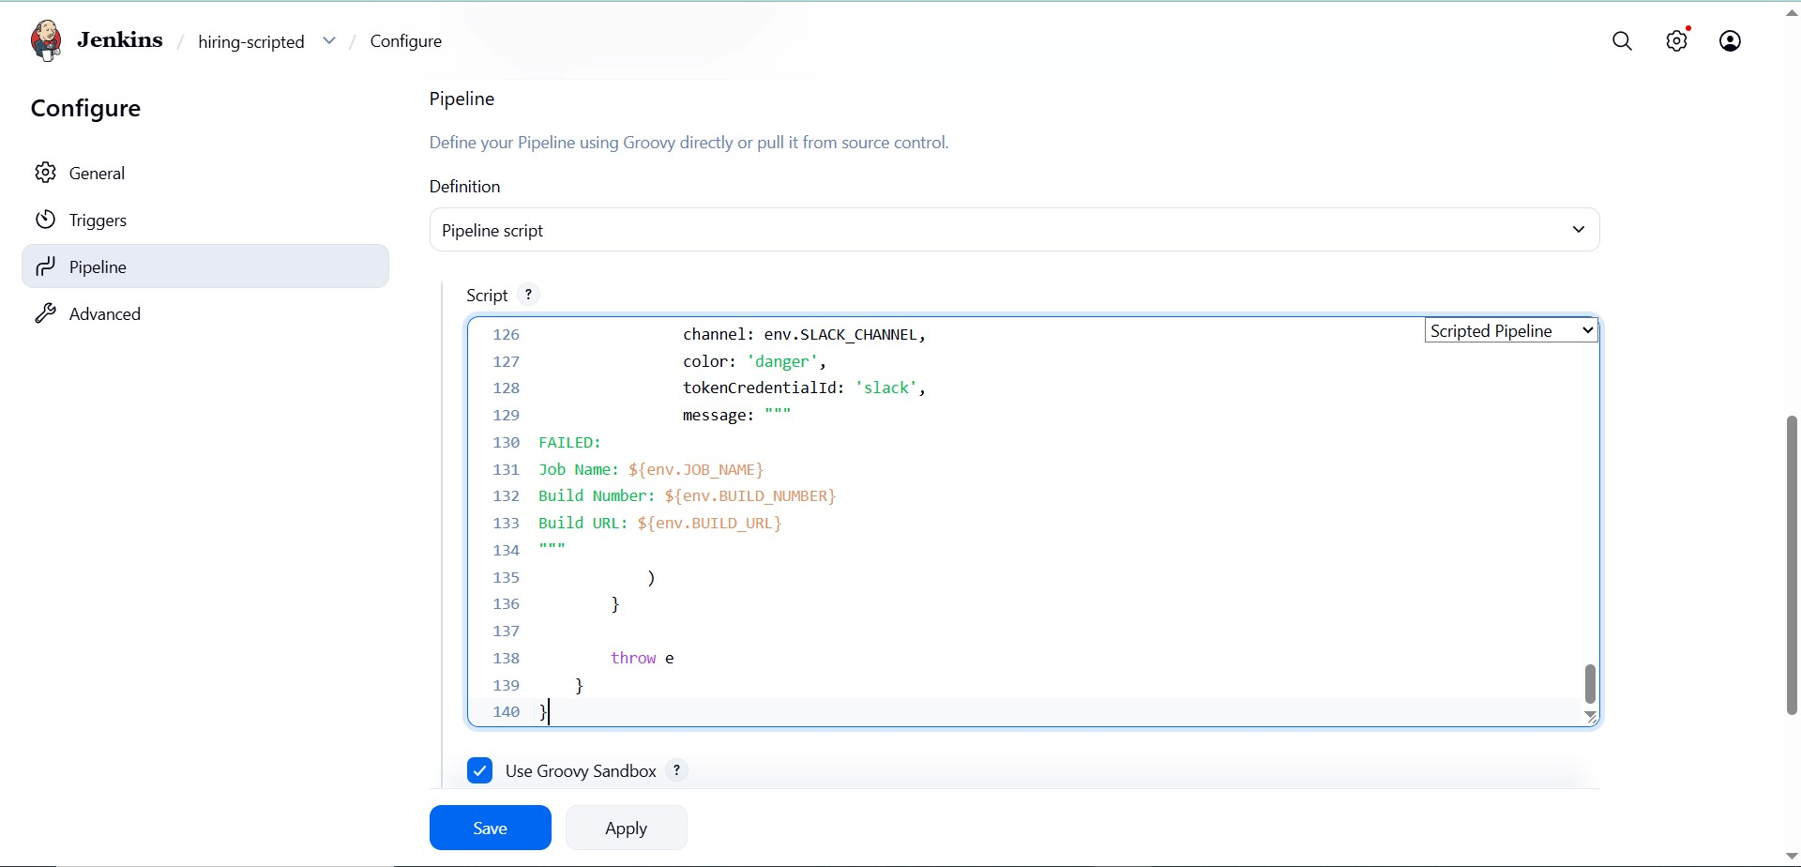

Build successfull
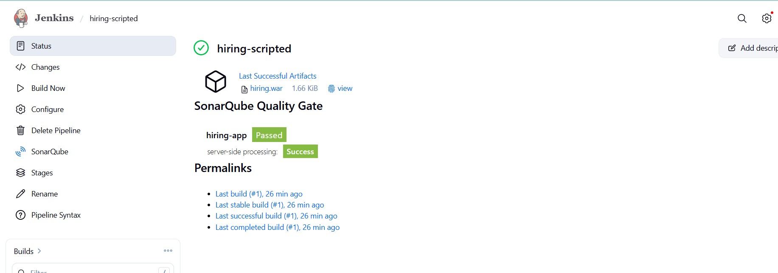

Check console output
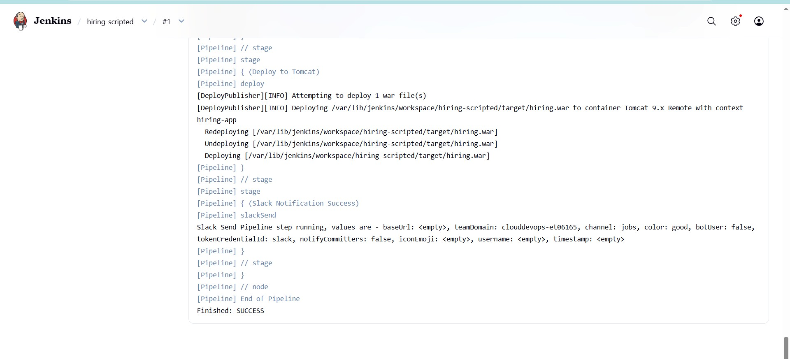

Slack notification
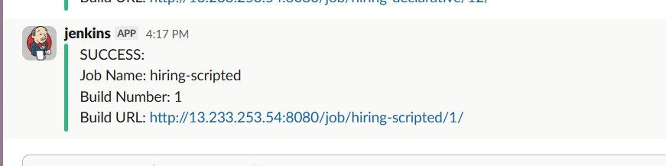

- Create one multi stage pipeline job

multi stage pipeline job:
here is a proper Multi-Stage Declarative Jenkins Pipeline using:
- GitHub
- Maven
- SonarQube
- Nexus
- Tomcat
- Slack
This pipeline separates each CI/CD activity into independent stages.

Create new item→select pipeline→configure
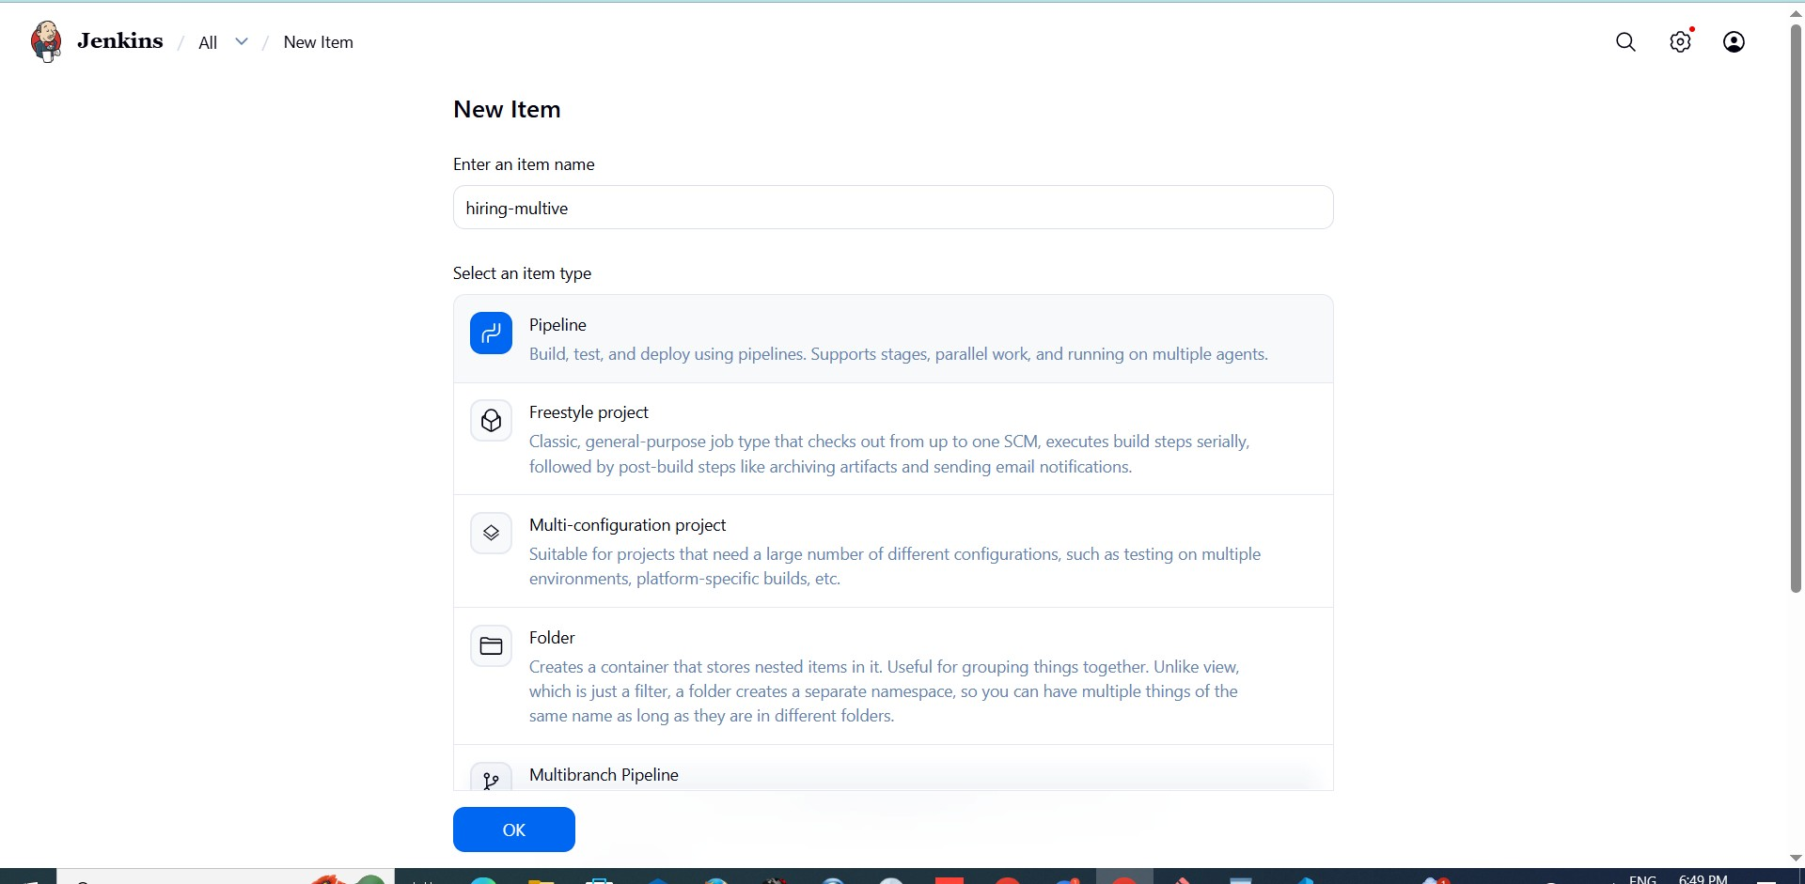
Write pipeline
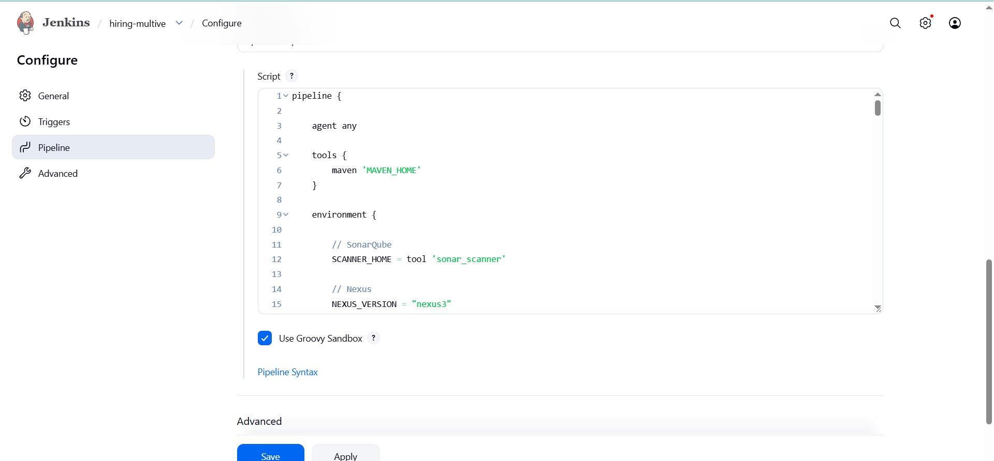

pipeline {

agent any

tools {
maven 'MAVEN_HOME'
}

environment {

// SonarQube
SCANNER_HOME = tool 'sonar_scanner'

// Nexus
NEXUS_VERSION = "nexus3"
NEXUS_PROTOCOL = "http"
NEXUS_URL = "13.232.205.190:8081"
NEXUS_REPOSITORY = "hiring-app"
NEXUS_CREDENTIAL_ID = "nexus"

// Artifact Details
GROUP_ID = "in.javahome"
ARTIFACT_ID = "hiring"
VERSION = "1.0.${BUILD_NUMBER}-SNAPSHOT"

// Tomcat
TOMCAT_URL = "http://13.201.30.120:8080/"
TOMCAT_CREDENTIAL_ID = "tomcat"

// Slack
SLACK_CHANNEL = "jobs"
}

stages {

stage('Stage-1: Clean Workspace') {
steps {

cleanWs()
}
}

stage('Stage-2: Clone Source Code') {
steps {

git branch: 'main',
url: 'https://github.com/betawins/hiring-app.git'
}
}

stage('Stage-3: Validate Project') {
steps {

sh 'mvn validate'
}
}

stage('Stage-4: Compile Application') {

steps {

sh 'mvn compile'
}
}

stage('Stage-5: Run Unit Tests') {
steps {

sh 'mvn test'
}
}

stage('Stage-6: SonarQube Analysis') {
steps {

withSonarQubeEnv('sonarqube') {

sh """
${SCANNER_HOME}/bin/sonar-scanner \
-Dsonar.projectKey=hiring-app \ -Dsonar.projectName=hiring-app \ -Dsonar.sources=.
"""
}
}
}

stage('Stage-7: Package WAR File') {
steps {

sh 'mvn clean package'
}
}

stage('Stage-8: Archive Artifact') {
steps {

archiveArtifacts artifacts: 'target/hiring.war'
}
}

stage('Stage-9: Upload Artifact to Nexus') {
steps {

nexusArtifactUploader(

nexusVersion: NEXUS_VERSION, protocol: NEXUS_PROTOCOL, nexusUrl: NEXUS_URL, repository: NEXUS_REPOSITORY, credentialsId: NEXUS_CREDENTIAL_ID, groupId: GROUP_ID, version: VERSION,

artifacts: [
[
artifactId: ARTIFACT_ID, classifier: '', file: 'target/hiring.war', type: 'war'
]
]
)
}
}

stage('Stage-10: Deploy WAR to Tomcat') {
steps {

deploy adapters: [ tomcat9(
credentialsId: TOMCAT_CREDENTIAL_ID, path: '',
url: "${TOMCAT_URL}"
)
],

contextPath: 'hiring-app', war: 'target/hiring.war'
}
}

stage('Stage-11: Verify Deployment') {
steps { sh """
curl -I http://13.201.30.120:8080/hiring-app
"""
}
}
}

post {

success {

slackSend(
channel: "${SLACK_CHANNEL}",
color: 'good', tokenCredentialId: 'slack', message: """
SUCCESS:
Multi-Stage Pipeline Completed Successfully

Job Name: ${env.JOB_NAME}
Build Number: ${env.BUILD_NUMBER}
Build URL: ${env.BUILD_URL}
"""
)
}
failure {

slackSend(
channel: "${SLACK_CHANNEL}",
color: 'danger',
tokenCredentialId: 'slack', message: """
FAILED:
Multi-Stage Pipeline Failed

Job Name: ${env.JOB_NAME}
Build Number: ${env.BUILD_NUMBER}
Build URL: ${env.BUILD_URL}
"""
)
}
}
}

save& build
Build successfull
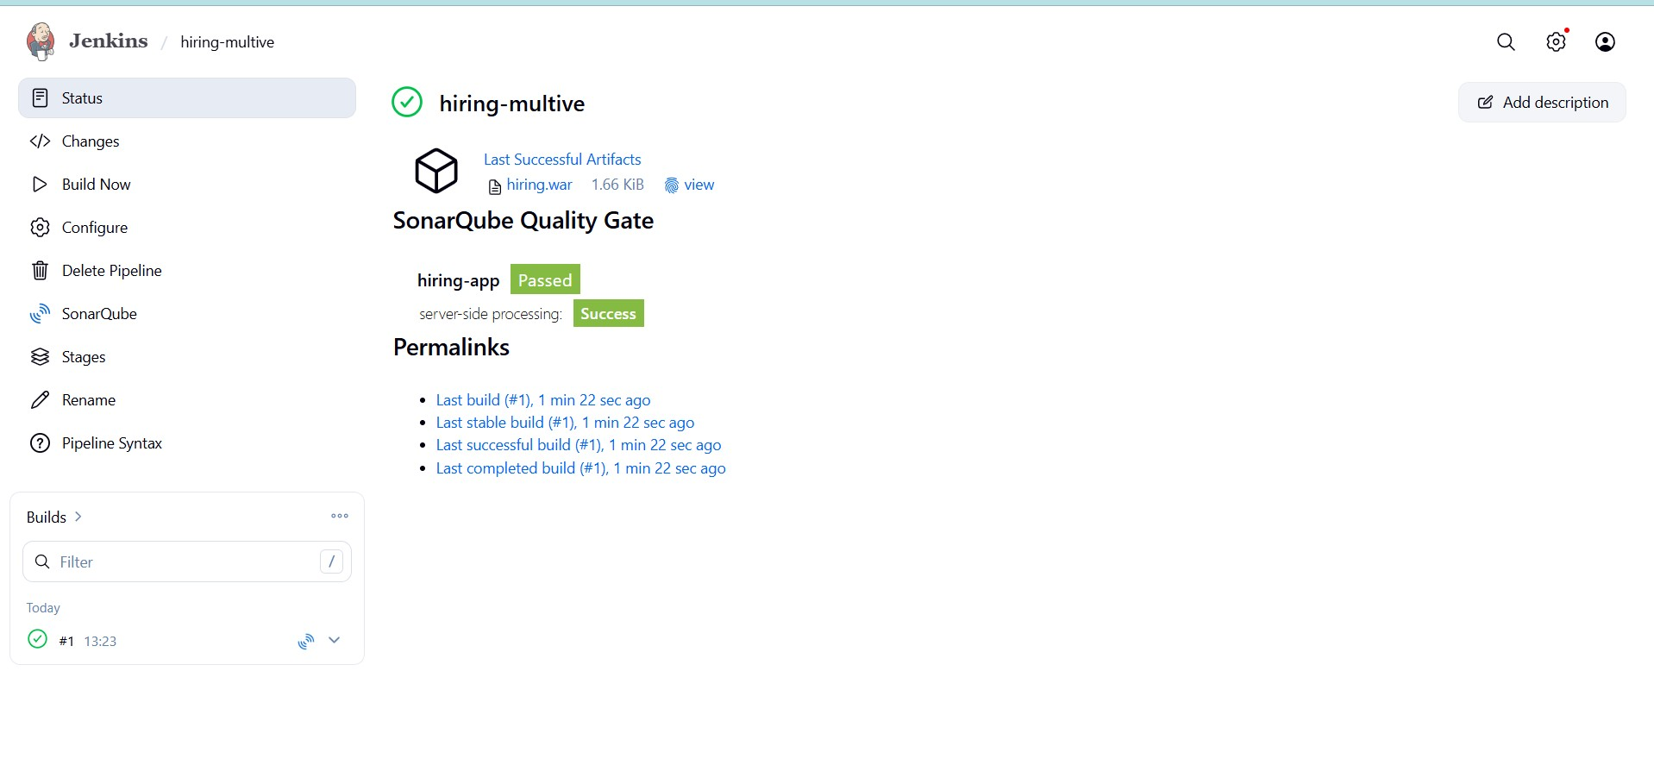

Console output
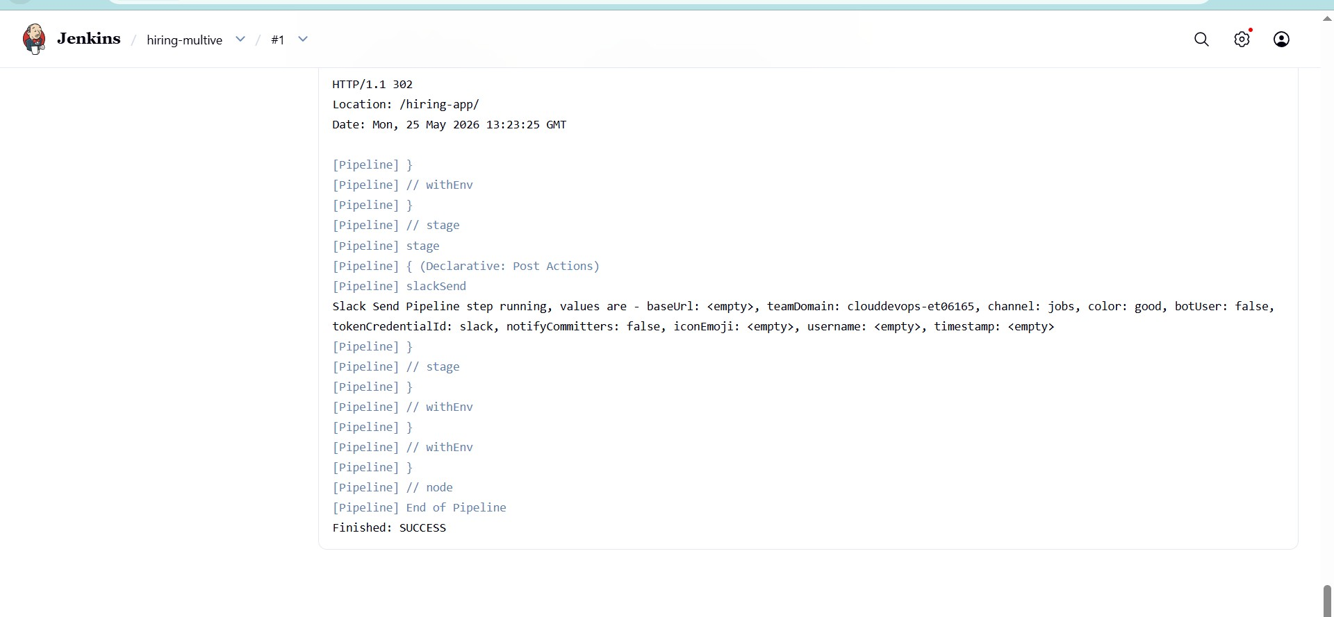
Slack notification
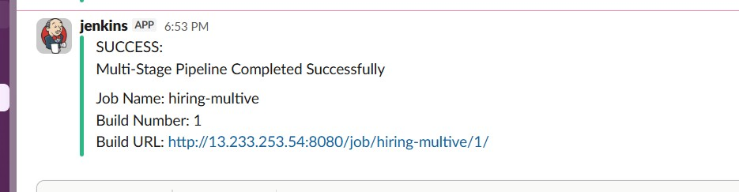
- Create one parallel stage pipeline job

parallel stage pipeline job:
This pipeline runs multiple stages simultaneously to reduce build time.
The following stages run together:
- Unit Tests
- SonarQube Analysis ● Security/Code Validation
This improves CI/CD performance.

Create new item→select pipeline→confugure
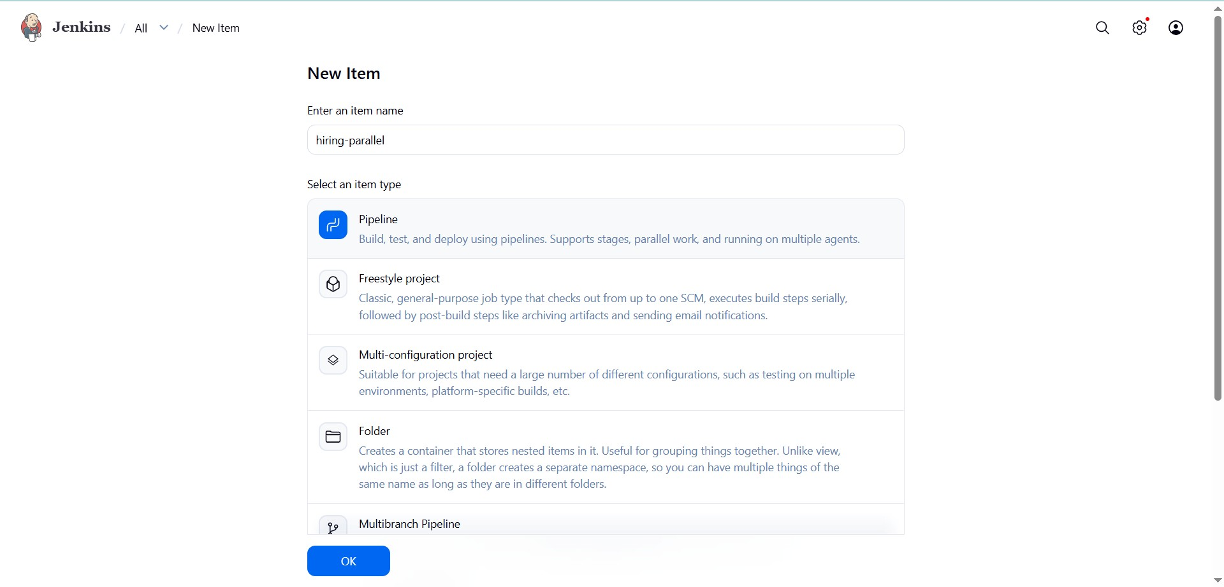
Write pipeline
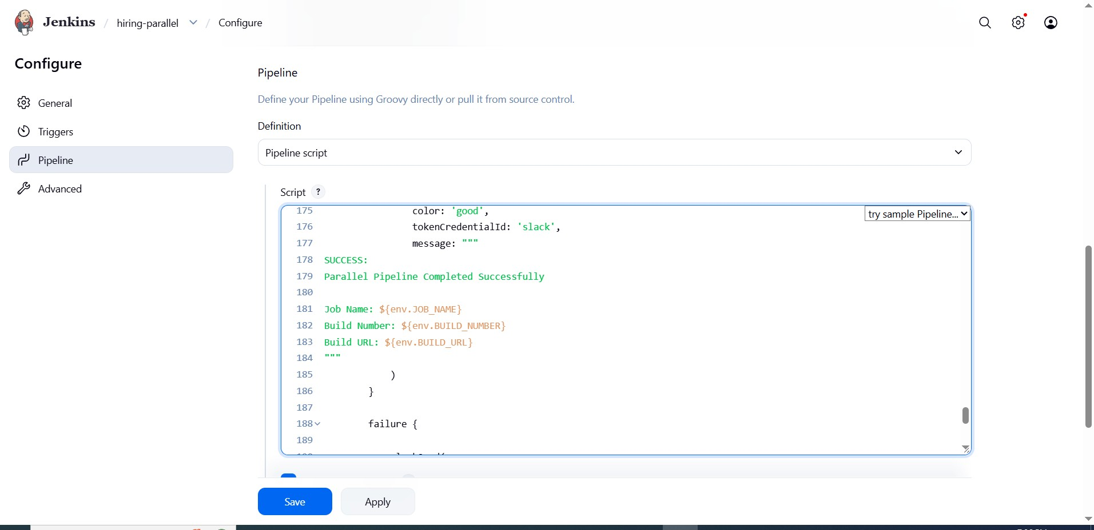

save&build
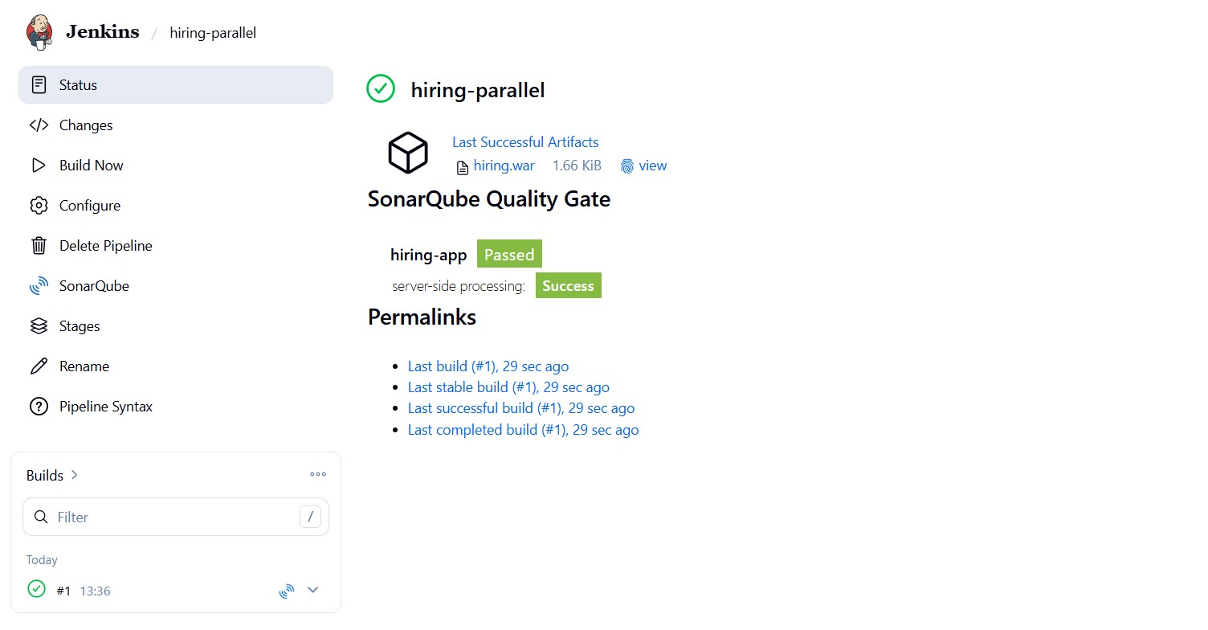
Console output
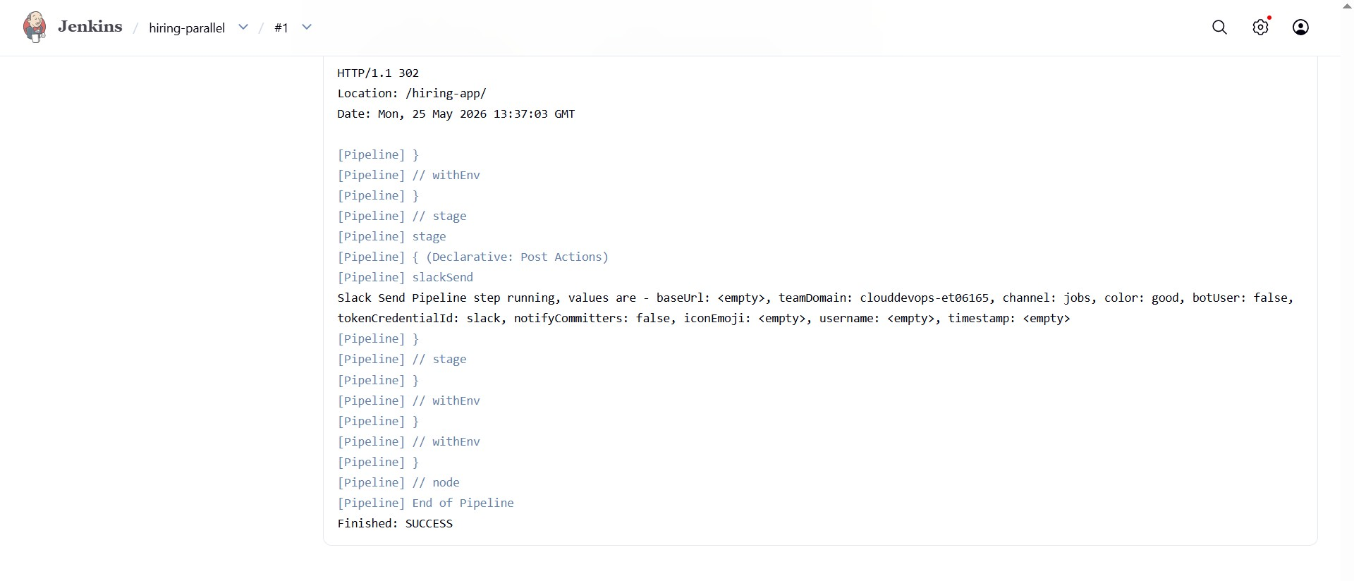

Slack notification
